25 July 2013

SUBJECT: MINUTES OF THE LEAVENWORTH COMMUNITY SERVICE ORGANIZATION (CSO) QUARTERLY MEETING HELD THURSDAY 25 July 2013

1. The Leavenworth Community Service Organization conducted its quarterly meeting on Thursday, July 25, 2013 at the Richard Allen Cultural Center & Museum, 412 Kiowa Street, Leavenworth, Kansas. Advance notice of the meeting sent to members proposed the following discussion topics:

- Updates to the contact roster
- Updates to the community calendar
- Jazz by the River 2013 Support
- Other concerns for the good of the order

2. Organizational representatives were asked to sign-in and check the information on the contact roster. Leavenworth CSO officers and organizations present and represented are listed on sign-in sheet. (See attachment 1)

3. The meeting agenda was as follows:
- Sign-in
- Welcome & Opening Prayer
- Introductions & Roster Review
- Agenda/ Minutes …Adopted/Approved
- Historical Review
- Financial Status Report
- Year-End Cookout Budget Report
- Calendar Review
- Jazz By The River 2013
- Way Ahead (Next Meeting)
- Closing Prayer

4. The meeting was called to order at 7:00 pm by CSO President Ron Coaxum with welcome remarks and an opening prayer. Each attendee introduced him/herself and their organization. The roster was reviewed; CSO reps not in attendance were acknowledged during the roster review.

5. Rik E. Jackson, CSO Vice President, made a motion to adopt the agenda as printed. The motion was seconded by Johnnie Jones, Omega Psi Phi, and approved unanimously. Minutes from April 11, 2013 quarterly meeting were read. Laura Coaxum (CSO Secretary) made a motion to accept the minutes as written with no corrections. The motion was seconded by Rik E. Jackson and approved unanimously.

6. CSO Secretary Laura Coaxum presented a brief historical review of CSO activities.

7. The current balance in the CSO account is $4445.81. The balance from the last quarterly report has a net decrease of $687.07 due to income and expenses from the annual CSO Cookout held on Sunday, Jun 9, 2013.

8. Ron Coaxum reported the final budget report for the community-wide cookout. (See attachment 2)

9. The calendar review was conducted and affiliated organizations’ events were shared through September 2013.

- 27 July---Mason’s Carwash
- 27 July---Sigma’s Scholarship Fundraiser (George Washington Carver)
- 27 July---Back to School GiveAway
- 3 Aug---JBTR Pre-party
- 3 Aug---Omega’s Ldrship Conference
- 7 Aug---ROCKS Meeting
- 10 Aug---PAIR Day
- 30 Aug---Omega’s Golf Tournament
- 17 Aug---JBTR
- 7 Sep---The Socialite Club will celebrate its 50th Anniversary at June’s Northland Hall

Many of the events acknowledged during the calendar review are included in the weekly CSO Newsletter available at http://www.lvncso.org. If your events are not included, please send upcoming events via digital flyers that are ready for posting to: info@lvncso.org ; or rcoaxum@kc.rr.com; or Vengeance4rdi@aol.com; or annsmoss@hotmail.com All members are asked to support events going on in the community by attending (if possible), or spreading the word by inviting others to support.

10. The 6th Annual Jazz by the River Fundraising Concert benefiting the Richard Allen Cultural Center will take place on Saturday, August 17, 2013, at the Leavenworth High School Performing Arts Center.
The RACCM has invited all community service organizations to partner with them in this important
community-wide event that supports tutoring and mentoring programs for our youth.
Partner organizations will receive a 25% rebate on their total ticket sales for ten(10), or more tickets sold.

11. The “Year-end” cookout was held on Sun, June 9, 2013 on the backyard grounds of PB&J Family Entertainment Center at 738 Eisenhower Road. Feedback from the cookout was all positive. Meal tickets were $3 each. 160 meal tickets were sold in advance and 24 purchased meals at the door. Overall, 148 meals were served. The menu consisted of Fried Chicken, Smoked Brisket, Baked Beans, Potato Salad, Hot Dogs, Chips, Peach Cobbler. Can sodas, juices and water were available as drinks. Two large tents were rented from outdoor recreation and put together by members of the set-up team. One person from each organization comprised the set-up team. Setting up the two large tents was very challenging, and the sun was very hot. Next year we will contract “Big T” Tents and have them set the tents up as we’ve done in the past. All “Big T” tents were sold out this year. We need to reserve earlier in the year before April. Three retail vendors also set-up this year, and sold their goods. Regina Dykes, the Jewelry Bee, Lee Wilson, Greek4U and Kondra Gibson, MyDiva Boutique were the vendors who provided their own tables, chairs and tents.

12. The meeting was adjourned at 7:45 p.m. The next COMMUNITY SERVICE ORGANIZATION (CSO) QUARTERLY MEETING is scheduled for October 11, 2013 at 7:00 pm at the Richard Allen Cultural Center. All organizations are urged to have a representative present to discuss/conduct the business of the CSO.

Respectfully Submitted,

Laura J. Coaxum, Secretary
Leavenworth Community Service Organization

Attachments: 2

Subject: Attachment 1 of meeting minutes for 25 July Quarterly Meeting

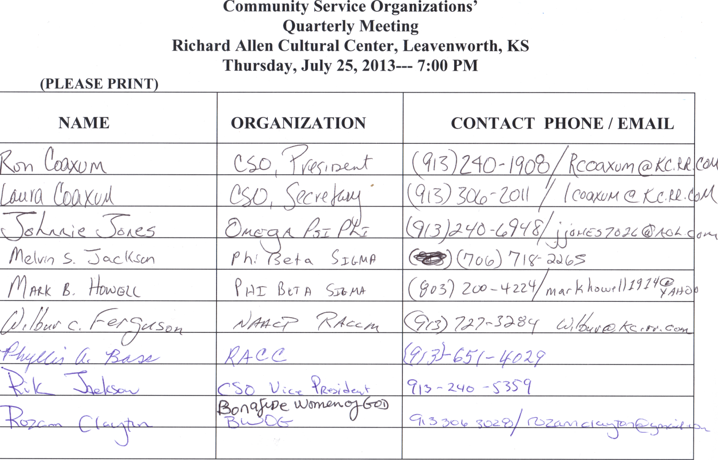

Subject: Attachment 2 of meeting minutes for 25 July Quarterly Meeting

