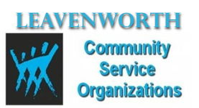
Community Service Organizations’ Year-End Cookout and Farewell
Sunday, June 7, 2015 (1-5 p.m.)
JD’s Dance Hall (PB&J) Family Entertainment Center
738 Eisenhower Road, Leavenworth, KS 66048

PROGRAM
11 a.m. – 1: p.m. --- Set-Up Site ……… Reps from Each Organization
1:00 p.m. --- Music Starts……………. DJ Mac
1:30 p.m. --- Welcome/Purpose………………. Ron Coaxum, CSO President
1:40 p.m. --- Invocation/Blessing of Food…… Rev. Joann Uitenham, CSO Chaplain
1:45 – 3:00 p.m. --- Serving Line Opens (Meal Ticket Required)
2:00 – 3:00 p.m. --- Music by Mac
3:00 p.m. – 3:30 p.m. --- Presentations (Each CSO has two (2) minutes) to:
- Recognize scholarship recipients and others
- Farewell and present gifts to departing members
- Introduce new members
- Announce upcoming events or fundraisers

3:30 – 5:00 p.m. --- Music Continues

5:00 p.m. until complete --- Tear Down ……. Reps from Each Organization

Organizations Representative to Speak

